RON CARTER DISCOGRAPHY 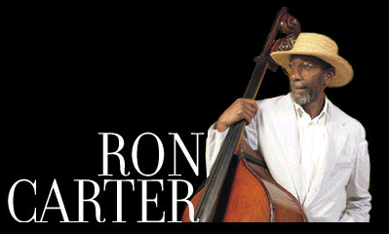

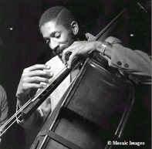
1.”Orfeu” Blue Note, 1999
2.”So What” Blue Note, 1998
3.”Bass & I” Blue Note, 1997
4.”Mr. Bow Tie” Blue Note, 1996
5.”Brandenburg Concerto” Blue Note, 1996
6.”Jazz, My Romance” Blue Note, 1994
7.”Friends” Blue Note, 1993
8.”Meets Bach” Blue Note, 1992
9.”New York Slick” Original Jazz Classics, 1997 (1979)
10.”Etudes” Discovery /Antones, 1994 (1982)
11.”Patrao” Original Jazz Classics, 1993 (1980)
12.”Third Plane” Original Jazz Classics, 1992 (1977)
13.”Pastels” Original Jazz Classics, 1991 (976)
14.”Peg Leg” Original Jazz Classics, 1991 (1977)
15.”Where?” Original Jazz Classics, 1990 (1961)
16.”Standard Bearers” Original Jazz Classics, 1988 (Comp.1972-79)
17.”Live At Village West” Concord Jazz, 1987 (1982)
18.”Telephone” Concord Jazz, 1987 (1984)
19.”Blues Farm” Columbia, 1987 (1973)
20.”Spanish Blue” Columbia, 1987 (1975)
21.”The Great Jazz Trio at The Village Vanguard” Inner City, 1979
22.”1+ 3”
23.”A Song For You”
24.”All Alone” EmArchy, 1988
25 “All Blues.”
26.”Alone Together” Original Jazz Classics, 1972
27.”Anything Goes”
28.”Birdology, Vol. 1”
29.”Birdology, Vol. 2”
30.”Duets”
31.”Heart and Soul”
32.”Live:ny 5/30/86”
33.”Out Front” 34.”Panmanhattan” Evidence, 1991
35.”Parade” Milestone, 1978
36.”Parfait”
37.”Piccolo” Milestone, 1977
38.”Ron Carter”
39.”Super Strings”
40.”Uptown Conversation “ Embryo, 1971
41.”Yellow and Green” CTI, 1976

RON CARTER’S SHORT BIOGRAPHY

Just being a part of the rhythm section in the justly famed Miles Davis Quintet from
1963 to 1968 is enough to place bassist Ron Carter among jazz's hierarchy.
The fact that he also has the capability for a serious music career and has
continued to follow his creative muse for the last 30 years is further tribute.
Carter, who also plays cello, bass guitar, violin, trombone, tuba and clarinet, was born
May 4, 1937, in Ferndale, Mich., and began the study of cello at age 10.
After high school studies in Detroit, Carter graduated from the Eastman School of Music,
worked in the Eastman Philharmonic, then Chico Hamilton's group in 1959.
He freelanced into the early '60s and earned his master's degree from the Manhattan School
of Music in 1961. Then in '63 opportunity knocked, as he joined the famed Davis quintet
along with Wayne Shorter, Herbie Hancock and Tony Williams.
Having played on more than 500 albums, Carter continues work as both leader and
sideman in a variety of settings. In addition to his work with Davis, particularly those
recordings with the group including Wayne Shorter, Carter's best efforts may be found on
the New Jazz (now OJC) recording Where? with Eric Dolphy and Mal Waldron and on his
duo outings with Jim Hall, including Telephone on the Concord label.
